**Caso 1.2.1: Frase 12.1**

**SAV guarda la fecha, el responsable, las observaciones, la identificación del comprador, la fecha acordada de entrega y el precio de venta del vehículo**

Freeling:

<NIL>12.1.</NIL>[SUJ-A0-AGT NP_SAV][VM VMIP_guardar.d1][CD-AL DA_la NCFS_fecha FC_, DA_el NCCS_responsable FC_, DA_las NCFP_observaciones FC_, DA_la NCFC_identificación SPS_del NCMS_comprador FC_, DA_la NCFS_fecha VMP_acordada SPS_de entrega CC_y DA_el NCMS_precio SPS_de NCFS_venta SPS_del NCMS_vehículo.]

**VMP: Verbo principal Participio (con función de Adjetivo en Arbol dependencias)**

SFN (http://gemini.uab.es:9080/SFNsite/sfn-tools/sfn-parser):

APRED: Adjetivo predicativo

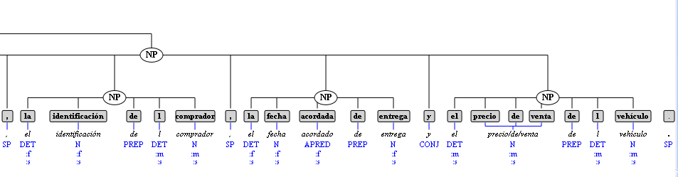

**SAV keeps the date, the head, the observations, the identification of the buyer, the date agreed of delivery and the sale price of the vehicle.**

COCLUSIÓN:

SAV keeps the date, the head, the observations, the identification of the buyer, **the agreed date** of delivery and the sale price of the vehicle.

[NP– SUJ – A0 NNP_SAV] [VP VBZ_keeps] [NP- OBJ_A1 DT_the NN_ date DT_the NN_ head DT_the NNS_ observations DT_the NN_ identification IN_ of DT_the NN_buyer DT_the NN_date VBN_agreed IN_ of NN_ delivery CC_ and DT_the NN_ sale NN_ price IN_ of DT_the NN_ vehicle]

Corpus:

[NP– SUJ – A0 NNP_SAV] [VP VBZ_keeps] [NP- OBJ_A1 DT_the NN_ date DT_the NN_ head DT_the NNS_ observations DT_the NN_ identification IN_ of DT_the NN_buyer DT_the NN_date VBD_agreed IN_ of NN_ delivery CC_ and DT_the NN_ sale NN_ price IN_ of DT_the NN_ vehicle]

Roth (Demo):

NP– SUJ – A0 NNP_SAV] [VP VBZ_keeps] [NP- OBJ_A1 DT_the NN_ date DT_the NN_ head DT_the NNS_ observations DT_the NN_ identification IN_ of DT_the NN_buyer DT_the [NP-?-A1 NN_date] [VP VBD_agreed] IN_ of NN_ delivery CC_ and DT_the NN_ sale NN_ price IN_ of [NP-? -A0 DT_the NN_ vehicle]]

VBD: Verb, Past Tense

VBN: Verb, Past Participle

Freeling (Demo Dependency parsing):

NP– SUJ – A0 NNP_SAV] [VP VBZ_keeps] [NP- OBJ_A1 DT_the NN_ date DT_the NN_ head DT_the NNS_ observations DT_the NN_ identification IN_ of DT_the NN_buyer [NP-SUJ-? DT_the NN_date] [VP VBD_agreed] [NP-OBJ-? IN_ of NN_ delivery CC_ and DT_the NN_ sale NN_ price IN_ of DT_the NN_ vehicle]]

Caso 131: frase 1

SAV muestra las matrículas de los vehículos habilitados.

SAV shows the registration numbers of the enabled vehicles

Se dejan igual

SAV obtains the quantity of units of the accessory that were rented.

SAV registers the data of closing of the lease.

SAV requests the description of the maintenance carried out to the vehicle.

(the insurance expiration date is greater than current date plus 1 month) and (total rate is greater than 0) and (mileage vehicle is less than 150000).

SAV requests the description of the damage that is desired to repair.

SAV encloses to the insurance policy the date and hour of registration and the identification of the Employee that registered it.

SAV shows the registration numbers of the vehicles that have insurance policies.

SAV obtains the identification of the Employee that carried out the renewal.

SAV obtains the identification of the Administrator that carried out the registration.

SAV registers the identification of the Administrator that carried out the registration.

* SAV obtains the identification of the Administrator that carried out the modification.
* SAV obtains the identification of the Employee that carries out the registration of the client.
* SAV obtains the identification of the Employee that carried out the modification of the client.
* SAV asks the Administrator if the client is direct or is an agency.
* Available quantity of the accessory is less than the quantity of units that are desired to hire.
* SAV obtains the registration date of the labor contract and the identifier of the Administrator that carries out said registration.
* SAV registers the code and the registration date of the labor contract, the identifier of the Administrator that carries out said registration, the identity card of the employee, the start date, duration and conditions of the labor contract.
* SAV obtains the modification date of the labor contract and the identifier of the Administrator that carries out said modification.
* SAV obtains the data of the labor contract in force that the employee maintains with the company.
* SAV obtains the annulment date of the labor contract and the identifier of the Administrator that carries out it.
* SAV registers the data of the labor contract, the annulment date and the identifier of the Administrator that carries out it.
* SAV obtains the registration date of the employee and the identifier of the Administrator that carries out it.
* SAV obtains the modification date and the identifier of the Administrator that carries out it.
* SAV registers the employee data, the modification date and the identifier of the Administrator that carries out it.